Bash Scripting Video 02 Task:
1.script to check if a directory is available or create a bash not: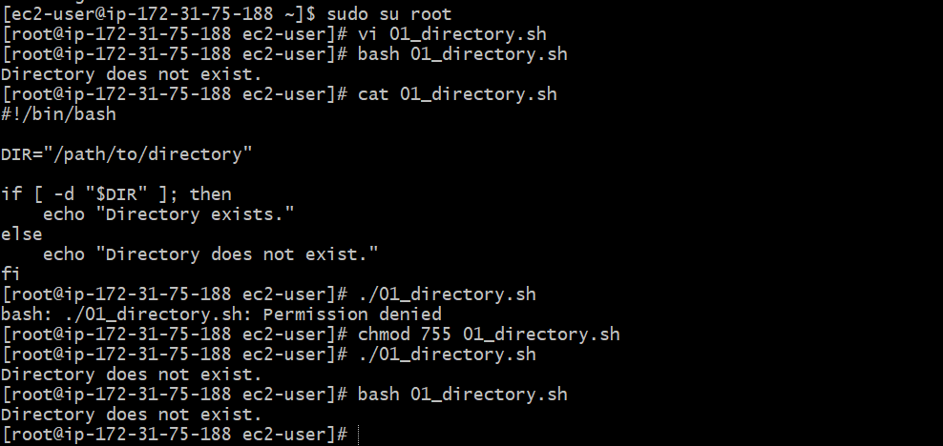

2.Create a bash script to create multiple files:
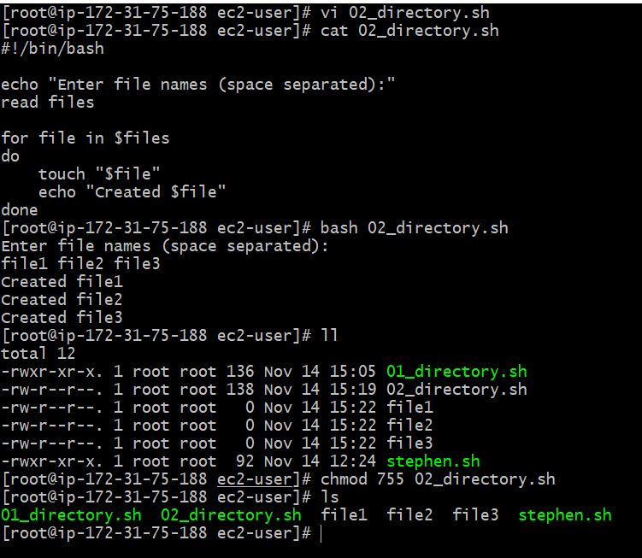
`
3.Create a bash script to take a backup of a directory: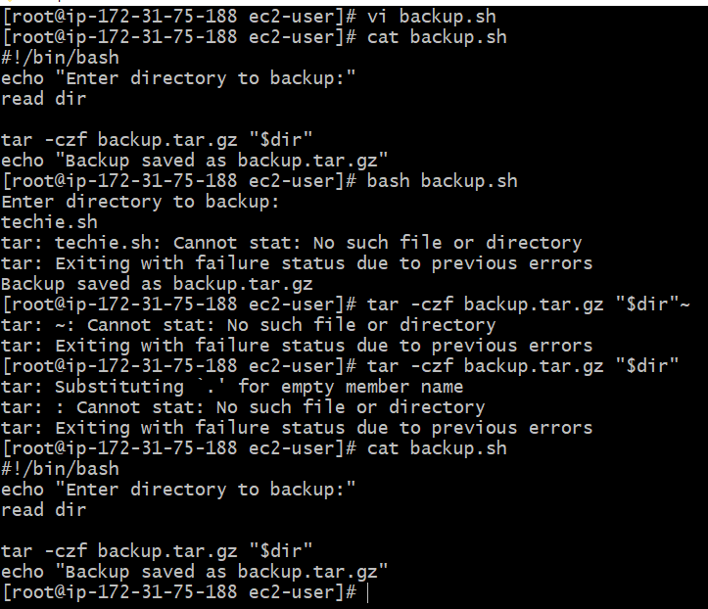

4.Create a bash script to install Nginx on an EC2 server:
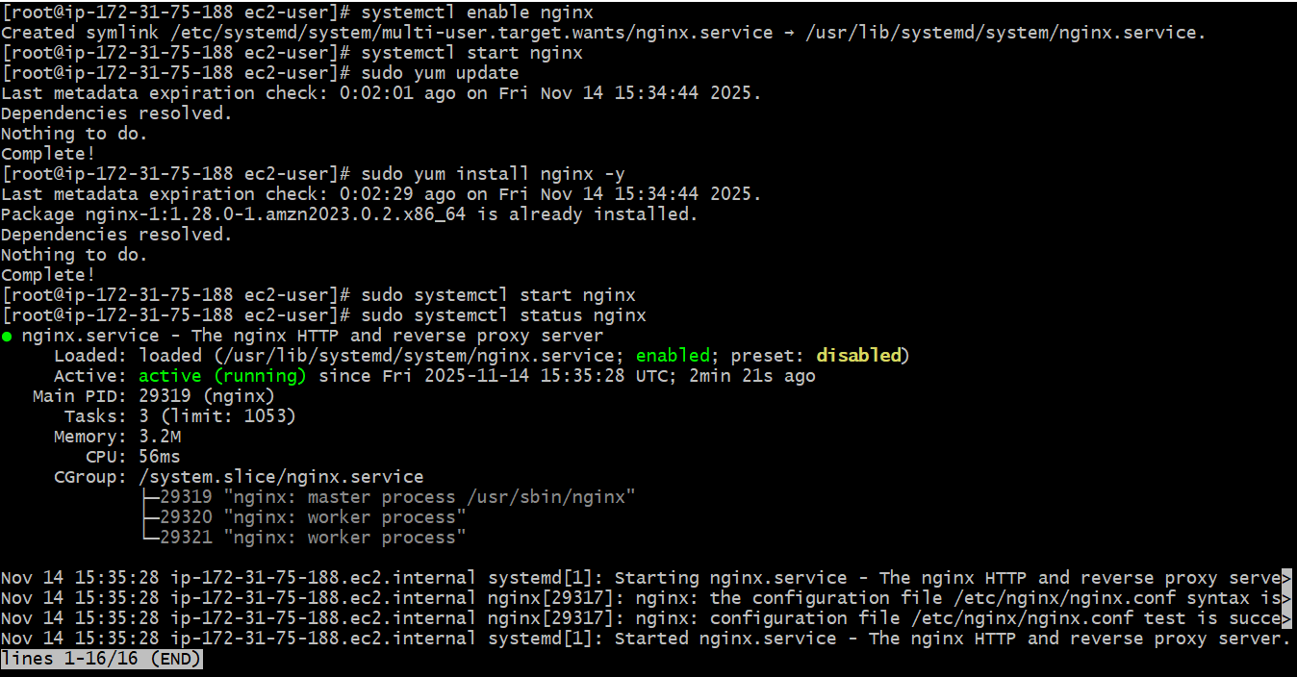
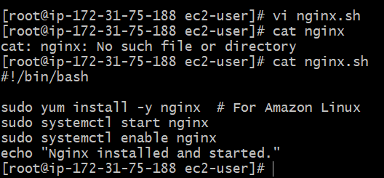
5.Create a bash script to install Apache Tomcat on an EC2 server:
Created a file, name as a tester.sh & edited the file with the script!
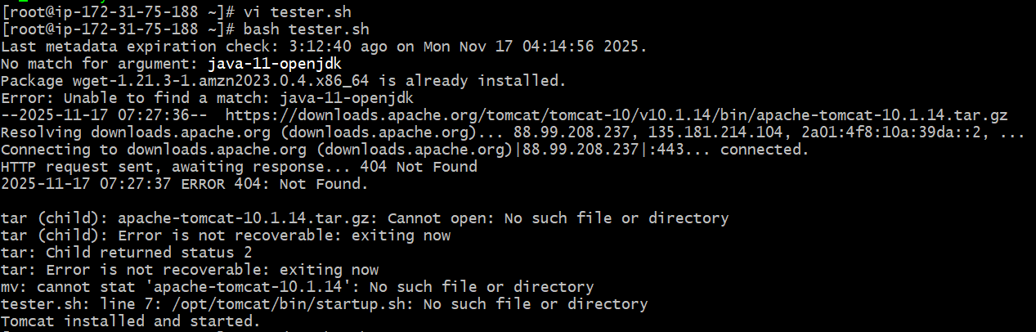
The Scripted file:
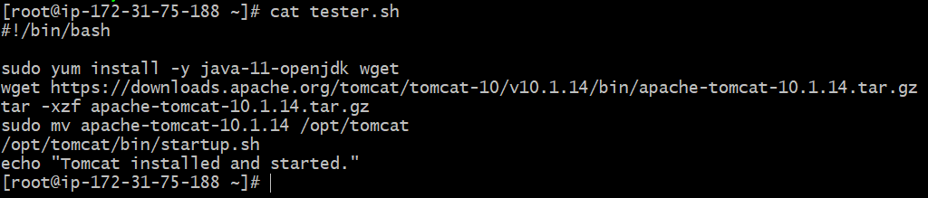

6. Create a bash script to check if the Nginx service is running, if not running then script should start the service:

Created a vi file & edited a script & run the file as a iphone.sh.
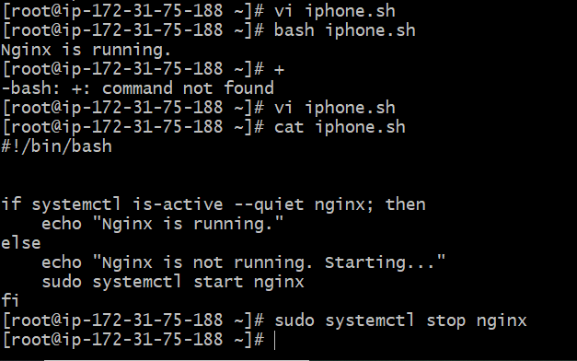
7.Create a bash script for a calculator:
First created a vi file as a name iphone.sh, then write a script & run the script.
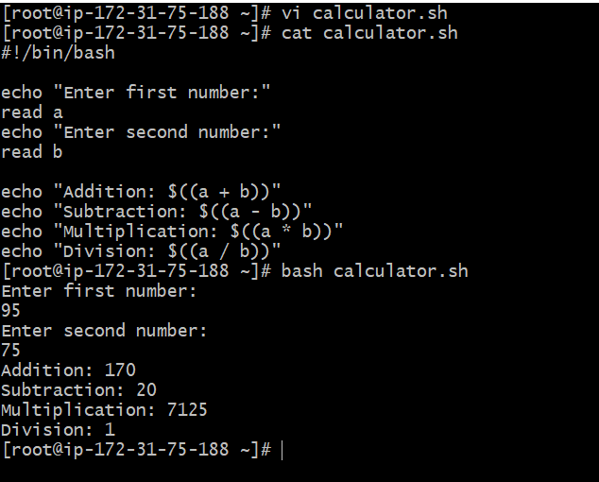

8.Create a bash script to check if a directory exists, if not then create a directory:
Created a vi file as a management.sh, then write a script. After the cat command, created a directory by using command “/tmp/myfolder” & run the file.
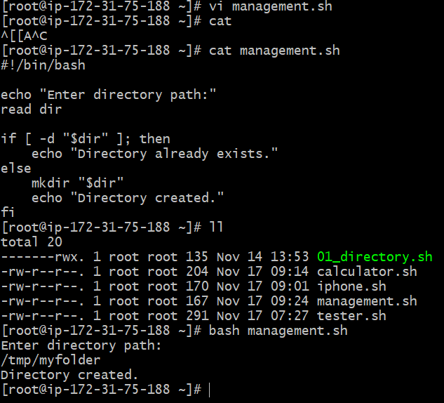
9.Create a bash script to delete the last 3 lines of a file:
Created a file, write the script & run the file.

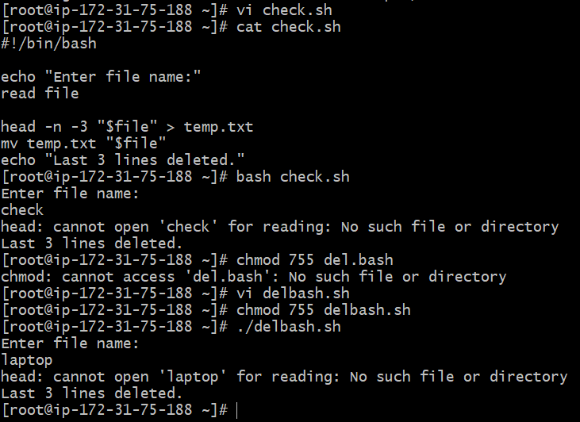

10.Bash script to monitor cpu and if it is more than 80% then send email notification:
Created a file as cpuinfo.sh, edited with the script & run the file.
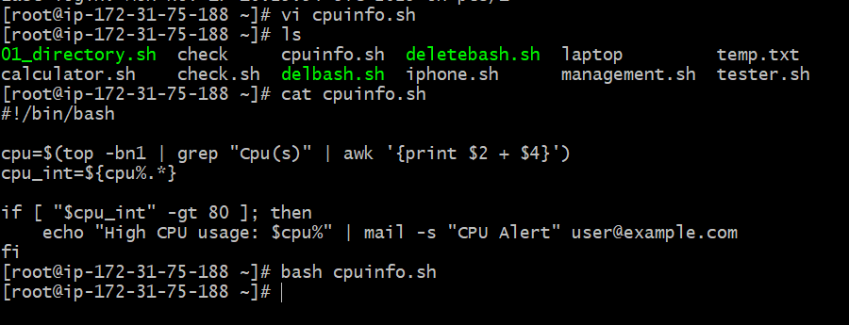
11.Bash script to monitor disk space and if it is more than 80% then send email notification:
created a Vi file name as disk.sh, written a script & run the file.
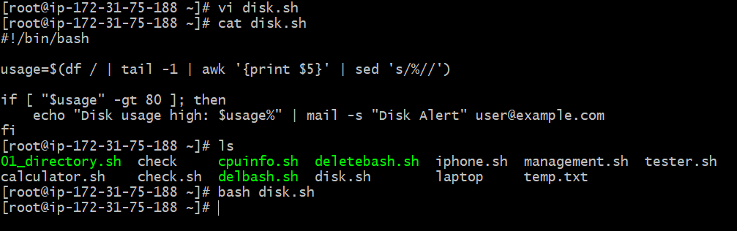

12.Bash script to monitor memory and if it is more than 80% then send email notification:
created a Vi file name as memory.sh, written a script & run the file.
